IV PIVOT EDITOR

Contents
1. Opening the pivot editor in Unity 1
2. Editing your pivot 1
3. Saving your modified meshes 1
4. Setting pivot on scene view 2
5. Setting pivot according to the bounding box 3
6. Setting custom world position and rotation to your pivot 3
7. Utilities 4

Opening the pivot editor in Unity
Opening the editor in Unity is pretty simple, just go to the “GameObject” menu and them “Set Pivot”

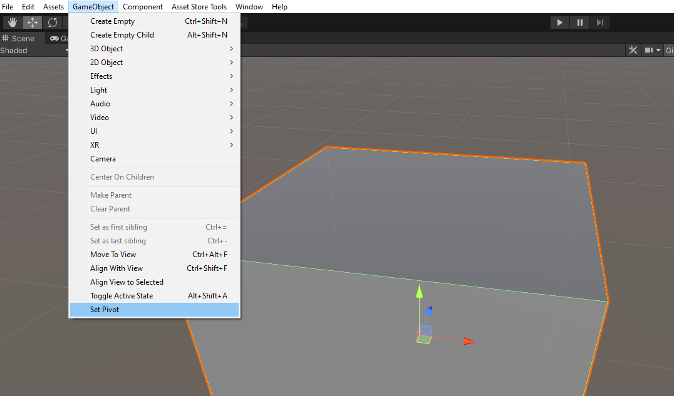

Editing your pivot
To start editing your pivot just select the object you want to modify and then click “Start Editing”

Saving your modified meshes
Unity won’t let me make changes to the original mesh files (fbx, obj) so we need to clone the mesh that we are going to modify and then save it in the “Assets” folder. When you try to modify your pivot for the first time the editor will automatically ask you to save the new mesh asset, unless you check “Save mesh to fbx folder”, which will automatically save the mesh asset in the same folder as your FBX file.

Setting pivot on scene view
To set the pivot on scene view you just need to toggle the option “Set On Scene”. If you also toggle “Snap to vertex” the pivot will automatically try to snap to the vertices of your mesh.
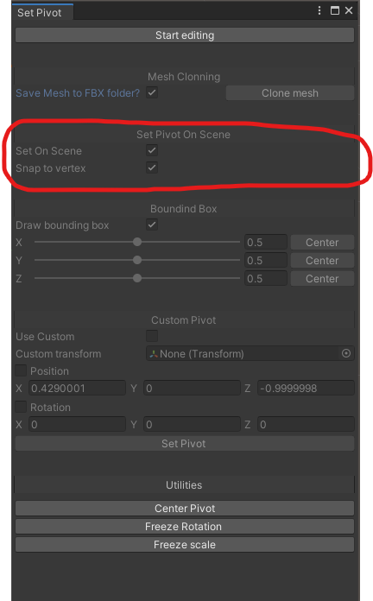

Setting pivot according to the bounding box
We provide you 3 sliders to set your pivot according to the bounding box of your object. Each slider will change the pivot in the given axis “x”, “y” or “z”

Setting custom world position and rotation to your pivot
Another way to set your pivot is to configure a custom transform and copy it’s position and rotation, or type the world position and rotation manually.
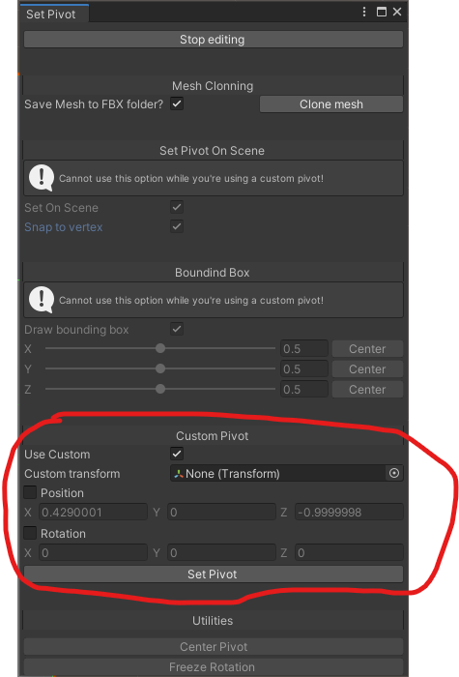

Utilities
IV Pivot Editor gives you 3 main useful tools that can make you handle not only your pivot, but your object original scale and rotation.
- Center Pivot: Lets you set your pivot to the center of the bounding box of your object
- Freeze Rotation: Lets you make the current rotation of your object zero
- Freeze Scale: Lets you make your object scale assume the values (1, 1, 1) for the “X”, “Y” and “Z” axes. That’s a very helpful feature if you are scaling your object non uniformly.

